Exploring the Determinants of Low Plasma Retinol and Beta-Carotene Levels in a Patient Dataset with Regression Analysis

Patrick Bacon
psbacon@ucdavis.edu
Thommas Phan
thtphan@ucdavis.edu

ABSTRACT
BACKGROUND:
Observational studies have found associations between low levels of both beta-carotene and retinol and the increased risk of developing certain types of cancer.⁽¹⁾⁽²⁾⁽³⁾ However, relatively few studies have investigated the determinants of low levels of plasma beta-carotene and plasma retinol. The authors designed a cross-sectional study to investigate the relationship between personal characteristics (e.g., age, sex, BMI) and dietary factors (e.g., vitamin intake, calorie intake, fiber intake), and plasma concentrations of beta-carotene and retinol.

OBJECTIVE:
This exploratory data analysis aims to uncover patterns, trends, and insights within the authors’ cross-sectional study to investigate the possible determining factors of low levels of plasma retinol and plasma beta-carotene. By employing regression analysis techniques and data visualizations, our objective is to provide a reliable linear interactive model to better understand and uncover the strongest determinants of plasma beta-carotene and plasma retinol levels within the population.

STUDY DESIGN:
The cross-sectional study provides data on variables (listed below) measured on 315 patients who had an elective surgical procedure during the three-year period to biopsy or remove a lesion of the lung, colon, breast, skin, ovary or uterus that was found to be non-cancerous.

AGE: Age (years)
SEX: Sex (1=Male, 2=Female)
SMOKSTAT: Smoking status (1=Never, 2=Former, 3=Current Smoker)
QUETELET: Body Mass Index (BMI) (weight/(height^2))
VITUSE: Vitamin Use (1=Yes, fairly often, 2=Yes, not often, 3=No)
CALORIES: Number of calories consumed per day
FAT: Grams of fat consumed per day
FIBER: Grams of fiber consumed per day
ALCOHOL: Number of alcoholic drinks consumed per week
CHOLESTEROL: Cholesterol consumed (mg per day)
BETADIET: Dietary beta-carotene consumed (mcg per day)
RETDIET: Dietary retinol consumed (mcg per day)
BETAPLASMA: Plasma beta-carotene (ng/ml)
RETPLASMA: Plasma Retinol (ng/ml)

Considerations of the selection bias of this study were taken into account, understanding that any conclusions from this study cannot be extrapolated to the general population, since all the data of this study were obtained from patients with recent surgical procedure to remove a lesion of various organs. As a result, the most meaningful conclusions of the model selected from this dataset will be to improve our understanding how the observed personal characteristics and dietary factors play a role in plasma levels of both beta-carotene and retinol within patients of similar nature.

With a sample population of n=313, (2 patients were removed due to unreliability of data, see Methods section) the model designers randomly selected n=200 (chosen to approximate a two-thirds/one-third split) for training data and n=113 for the external validation dataset. The training data was evaluated against the whole dataset to ensure a representative random sampling (e.g., ensuring categorical proportions were similar, quantitative data were similar, etc.)(Appendix 1.3).

The plan is to build multiple, diverse candidate models for two response variables: plasma beta-carotene and plasma retinol levels, after evaluating visualizations of the data and deciding which X variables would be most appropriate to use for each model. Once the candidate models are chosen, each candidate model will be tested against the external validation dataset, and the best performing candidate model will be chosen and refitted to include the entire dataset. We discuss the “best performing” models and what the regression coefficients possibly suggest.

BETA CAROTENE MODEL RESULTS
Young, heavier individuals who ate more fat and less fiber and beta-carotene in their diets are associated with lower beta-carotene levels in their plasma. Men were found to have less beta-carotene in their plasma. Lastly, the use of vitamins in one’s life in the dataset were associated with healthier levels of beta-carotene.

RETINOL MODEL RESULTS
Age, alcohol, and vitamin use were found to be associated with higher levels of retinol. These counterintuitive results are discussed in further detail.

CONCLUSION
The youth aspect of this statement may be surprising, but when considering that the dataset includes patients that have recently had a lesion removed, we can assume that those who need medical intervention earlier in their lifespan will generally have less favorable health indicators. Alcohol use being positively correlated is likely a case of selection bias in the population, where those that choose to drink less alcohol likely must do so out of necessity for their health, since they are less healthy to begin with. All other findings are expected, such as healthier diets and body compositions are associated with higher levels of vitamin A.
INTRODUCTION
Plasma beta-carotene levels reflect the concentration of the precursor to vitamin A, while plasma retinol levels indicate the presence of the active form of vitamin A, providing crucial insights into the body's vitamin A status, which many observational studies have found to have an inverse association with risk of developing multiple types of cancer.⁽¹⁾⁽²⁾⁽³⁾ However, relatively few studies have investigated the determinants of low levels of plasma beta-carotene and plasma retinol. The authors designed a cross-sectional study to investigate the relationship between personal characteristics (e.g., age, sex, BMI) and dietary factors (e.g., vitamin intake, calorie intake, fiber intake), and plasma concentrations of beta-carotene and retinol (response variables).

The cross-sectional study provides data on 14 variables (listed in the Abstract) measured on 315 patients who had an elective surgical procedure during the three-year period to biopsy or remove a lesion of the lung, colon, breast, skin, ovary or uterus that was found to be non-cancerous. Due to the nature of the selection bias of the dataset, the model designers cannot extrapolate to the general population, and have decided to build a model to best understand the patient population of this study. The regression analysis aims to answer any possible questions about the relationship of plasma levels of beta-carotene and plasma levels of retinol and the personal characteristics and dietary factors measured in the dataset: What are the strongest determinants of the response variables? Are any of the predictors unusual/unexpected? What are the possible explanations for these determinants being the strongest predictors in this dataset? How does selection bias play a role in this dataset?

METHODS
For the purposes of this analysis, of the 15 variables provided in this dataset: 2 variables are response variables (plasma level of beta-carotene and plasma level of retinol), 3 variables are categorical variables (sex, smoking status, and vitamin use), and the last 9 variables are qualitative variables. Since the plasma levels of beta-carotene were severely right-skewed, a box-cox procedure was applied with MLE=0, suggesting a log transformation is best. For the purposes of this study, the log of plasma levels of beta-carotene will be used, while plasma levels of retinol will remain untransformed.(Appendix 1.4,1.6) 200 data points were randomly selected to be training data while the remaining 113 data points were kept as external validation data.

Categorical data was initially plotted in pie charts and box plots against each response variable to find any potential obvious correlations, but correlation appeared weak for each one, albeit no unexpected trends. (e.g., higher levels of beta-carotene and retinol are linked with females, vitamin use, and less smoking.) The qualitative variables were then put in a pairwise scatter plot against each other as well as the response variables, to identify any multicollinearity, strong correlations with the responses, and possible outliers and incorrect data. The plots suggested high multicollinearity between dietary factors in the X variables, such as calorie consumption, fat consumption, fiber consumption, and cholesterol consumption, which is to be expected. Only weak linear trends could be identified, with no obvious quadratic or polynomial relationships between the variables. 2 data points were removed from the 315 total, since the data suggested one patient drank 200 alcoholic drinks per week and another had 0 beta-carotene in their plasma. As a result, only first-order terms and two-way interaction terms will be considered for this model.

Akaike’s Information Criterion (AIC) was used to evaluate the best candidate models for each response. Each response variable will have two possible candidate models, the best model with only first order terms considered, and the best model with first order terms and two-way interaction terms considered, according to forward stepwise AIC. “Not Often” and “Often” levels of vitamin use both corresponded with extremely similar distributions of the response variables (Appendix 1.3) and such, the model designers decided to combine the categorical levels down to “Yes” and “No” for vitamin use, for simplicity of interpretation. (With “Not Often” corresponding to “Yes.”)(Appendix 1.3) Each model was internally validated via Press criteria and Mallow’s Cp criterion. After internal validation, each model was externally validated through Mean Squared Prediction Error (MSPE) of the validation data, comparing each models’ own SSE/n. For all 4 models, MSPE is approximately the same distance from SSE/n, so the simplest model with only first-order terms was chosen. The first order models were then trained on the entirety of the n=313 dataset. (Appendix 1.1)

RESULTS
Table 1.1: First Order Model for log transformed beta-carotene levels
 | Coefficient | Std. Error | T-Statistic | p-value
(Intercept) | 5.0069 | 0.2590 | 19.3300 | < 2e-16
BMI | -0.0304 | 0.0063 | -4.8300 | 0.0000
Vitamin Use: Yes | 0.2919 | 0.0805 | 3.6270 | 0.0003
Dietary Beta | 0.00005 | 0.00003 | 1.6310 | 0.1038
Dietary Fat | -0.0028 | 0.0012 | -2.2500 | 0.0252
Dietary Fiber | 0.0267 | 0.0084 | 3.1810 | 0.0016
Sex: Male | -0.2722 | 0.1212 | -2.2460 | 0.0254
Age | 0.0073 | 0.0028 | 2.6120 | 0.0095

Table 1.2: First Order Model for retinol levels
 | Coefficient | Std. Error | T-Statistic | p-value
(Intercept) | 403.5288 | 44.7076 | 9.026 | < 2e-16
Age | 3.13 | 0.7716 | 4.056 | 0.0000632
Alcohol | 9.574 | 2.2875 | 4.185 | 0.0000372
Vitamin Use: Yes | 29.2831 | 23.7448 | 1.233 | 0.218

CONCLUSION
Beta-Carotene Model Findings
The first-order model performed better in AIC and MSPE, and slightly worse in MSE, SSE, and PRESS. The first-order model was chosen by the principle of parsimony, since the goal of this analysis is to interpret any meaningful relationships between the response variable, plasma beta-carotene in this case, and the patient population. Since the response variable is in log transformation, the interpretations of these coefficients are the percentage change of the response variable. 7 predictor variables were chosen via forward stepwise regression with AIC as the criteria for log plasma beta-carotene: BMI, Vitamin Use (categorical), dietary beta-carotene intake, dietary fat intake, dietary fiber intake, sex (categorical), and age, the coefficients can be referenced above in Table 1.1. The coefficient for BMI translates to people in the patient dataset with one unit larger BMI had 2.99% less beta-carotene levels. The beta-carotene coefficient translates to patients that had one mcg more of beta-carotene in their weekly diet had 0.005% higher levels of beta-carotene levels. The coefficient for weekly fat intake translates to those that ate one more gram of fat per week had 0.28% less beta-carotene levels. The coefficient for weekly fiber intake indicates those that ate one more gram of fiber per week had 2.71% more beta-carotene levels. Those that are one year older have 0.73% more beta-carotene levels. The categorical variables, Vitamin Use and Sex, have a positive coefficient of 0.2919 and negative coefficient of -0.2722, respectively. Since the response variable is log transformed, these can be interpreted as those that use vitamins have plasma levels of beta-carotene 33.9% larger than those who don’t. This is expected, as vitamins generally include vitamin A and other forms of vitamin that should improve health markers. The sex coefficient suggests males in the study have 23.8% less beta-carotene in their plasma.

Beta-Carotene Model Discussion
The results of the log transformed beta-carotene levels were unsurprising. To briefly summarize, young, heavier individuals who ate more fat and less fiber and beta-carotene in their diets are associated with lower beta-carotene levels in their plasma. Considering the dataset includes patients that recently had a lesion, we can assume that those who need medical intervention earlier in their lifespan will generally have less favorable health indicators. Men were found to have less beta-carotene in their plasma, although only 41 males were included in the study, opposed to 272 females.⁽⁴⁾ Lastly, the use of vitamins in one’s life in the dataset were associated with healthier levels of beta-carotene, which is expected as many vitamins include beta-carotene and vitamin A in their formulation. Although there collinearity between the dietary variables included in this model, (e.g., BMI, fat intake, fiber intake)(Appendix 1.2) none were removed from the model since each coefficient was significant by t-test. However, the study could be repeated with only BMI, the most significant indicator of beta-carotene levels, and would come to a similar conclusion. These results only apply to the specific subset of the population that recently had a surgical procedure to have a lesion removed.

Retinol Model Findings
The interaction model performed slightly better by AIC, MSE, and SSE, but the first-order model performed slightly better than the second-order model by PRESS, and substantially better than the interaction model by MSPE, suggesting the first-order model is more robust to overfitting. Comparable performance, in addition to the principle of parsimony, led us to select the simpler, more interpretable first order model. Referencing the coefficients above, the model contains 3 predictor variables: age, alcohol, and vitamin use as an indicator variable. Outlier detection was considered via Cook’s distance and Residual vs. Leverage plots, and none were detected that weren’t already removed. (Appendix 1.9) All 3 coefficients are positive. The intercept is not interpretable as our data contains no patients with age 0. A 1 year increase in age, holding all other variables constant, corresponds to a 3.13 unit increase in plasma retinol (ng/ml). A 1 drink increase in weekly drinks, corresponds to a 9.57 unit increase in plasma retinol. On average, vitamin use corresponds to a 29.28 increase in plasma retinol.

Retinol Model Discussion
The strong relationship between vitamin use and the plasma concentrations of retinol is not surprising. What is unexpected is age and alcohol are both positively correlated with plasma retinol. All else equal, we expect older individuals who drink more alcohol to be more prone to poor health;⁽⁵⁾ low levels of plasma retinol being an indicator of poor health. Thus, we’d expect low levels of plasma to be associated with older individuals who drink more. In practice, we observe the opposite. One hypothesis for this result is selection bias; all 313 of the patients included in our final data set had recently had an elective surgical procedure to remove a non-cancerous lesion and is not representative of the population. Benign tumors appear more frequently in older individuals ⁽¹⁾, and thus a non-cancerous tumor developing in a younger individual is a stronger indicator of the presence of underlying health conditions than it is for an elderly individual. On a similar note, individuals with poor health conditions may be forced to severely limit or entirely cease their alcohol consumption, whereas individuals in better health will follow alcohol consumption patterns more in line with those of the general population.

Overall Discussion
Findings from this study are limited due to sampling bias likely being the main factor for unexpected results. Older individuals were correlated with healthier markers in both models, which shines a light on a young individual developing a non-cancerous tumor suggestive of being in poorer health than a “typical” case of developing a non-cancerous tumor later in life. While study objective was not to provide advice, we’d be remiss if we did not clearly state that our results do not suggest one should drink alcohol more frequently if they wish to increase their retinol plasma levels and improve their general health.⁽⁵⁾ They suggest, among this sample, these factors were positively correlated with retinol plasma levels, which are considered an indicator of general health. An interesting follow-up study could compare this population to the general population.
APPENDICES

Appendix 1.1: Model Validation Process Table
 | AIC | MSE | SSE | PRESS | MSPE | CP
First Order - Beta | -161.93 | 0.43 | 82.16 | 88.99 | 0.4871 | 4.96
Second Order - Beta | -162.48 | 0.42 | 80.31 | 88.87 | 0.4982 | 9.75
First Order - Retinol | 2103 | 36143.63 | 7084151 | 7414686 | 45523 | 1.69
Second Order - Retinol | 2101.2 | 35644.46 | 6950671 | 7518466 | 48028 | 2.87

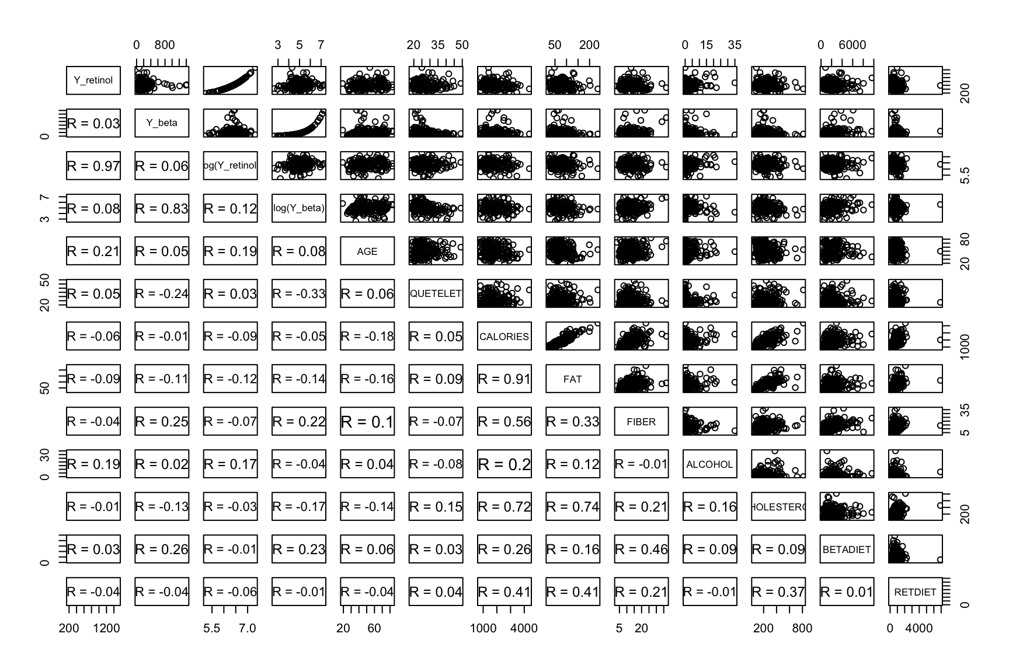
Appendix 1.2: Pairwise Scatter Plot
Appendix 1.3: Categorical Variables Vs. Response Variables
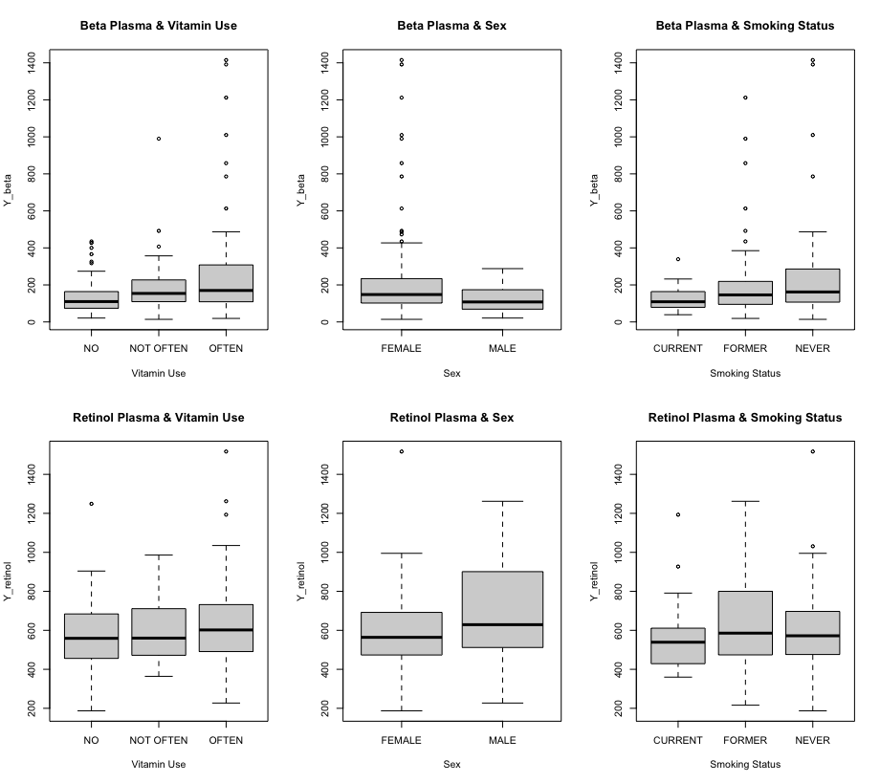

Appendix 1.4: Distributions of Response Variables (Pre-Transformation)
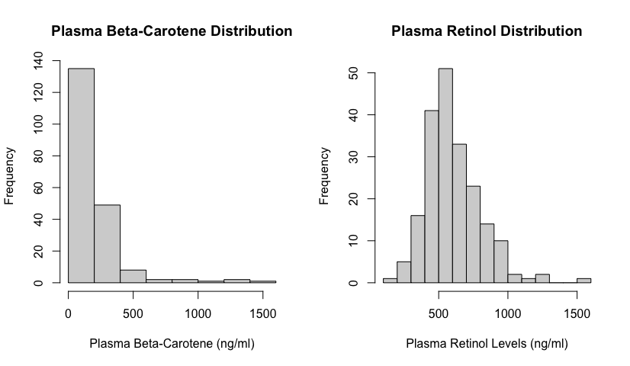

Appendix 1.5: Diagnostic Plots (Initial Full Model Fit)
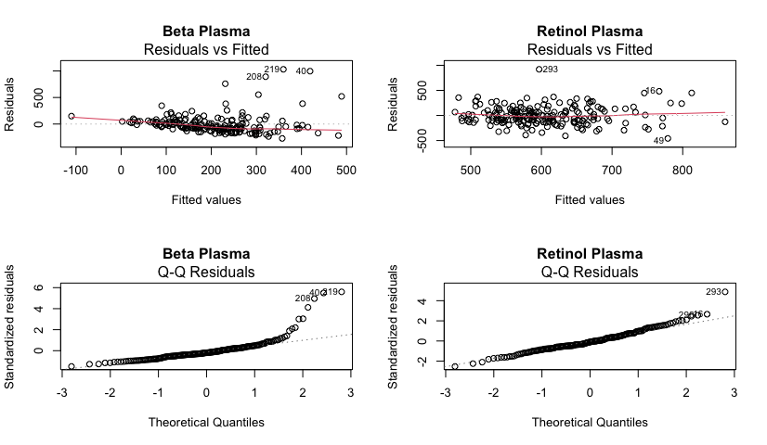

Appendix 1.6: Box Cox Transformation (Beta Plasma) & Updated Distribution
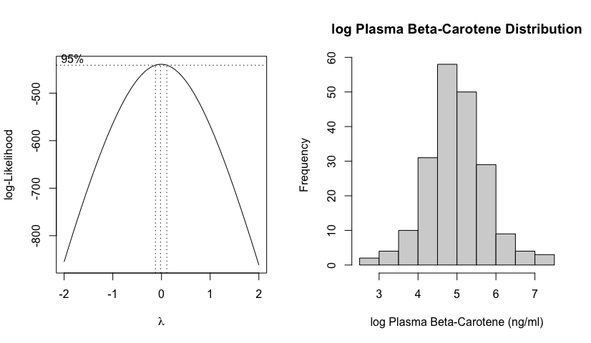

Appendix 1.7: Diagnostic Plots for log Beta Plasma (Initial Full Model)
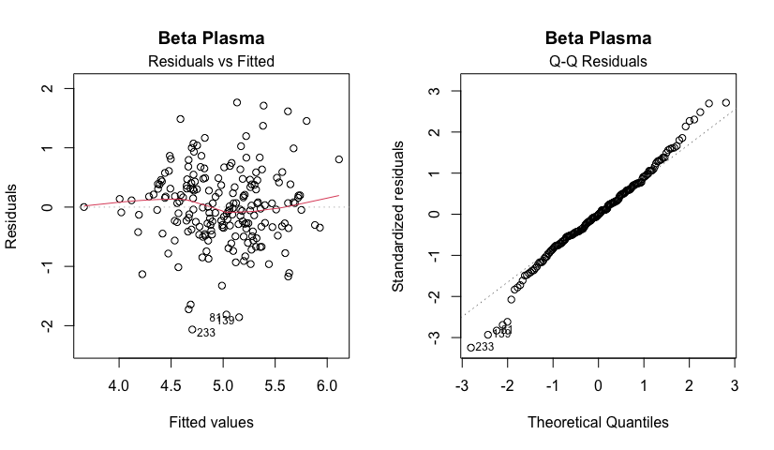

Appendix 1.8: Diagnostic Plots (Final Model Fit - Full Dataset)
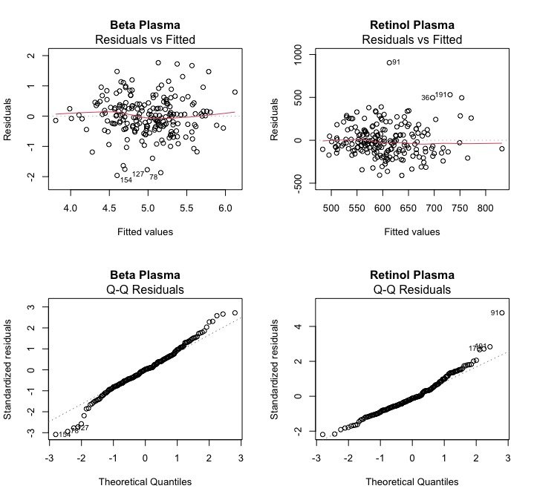

Appendix 1.9: Residuals Vs. Leverage Plots (Final Model Fit - Full Dataset)
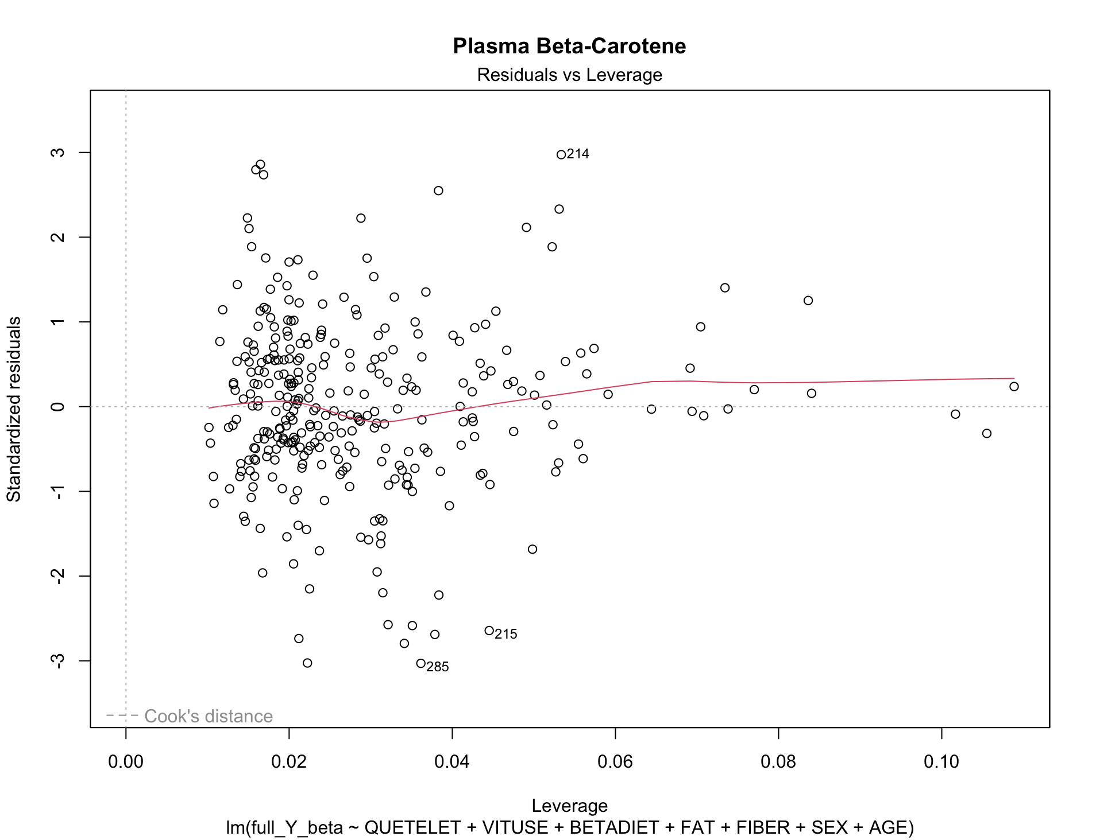
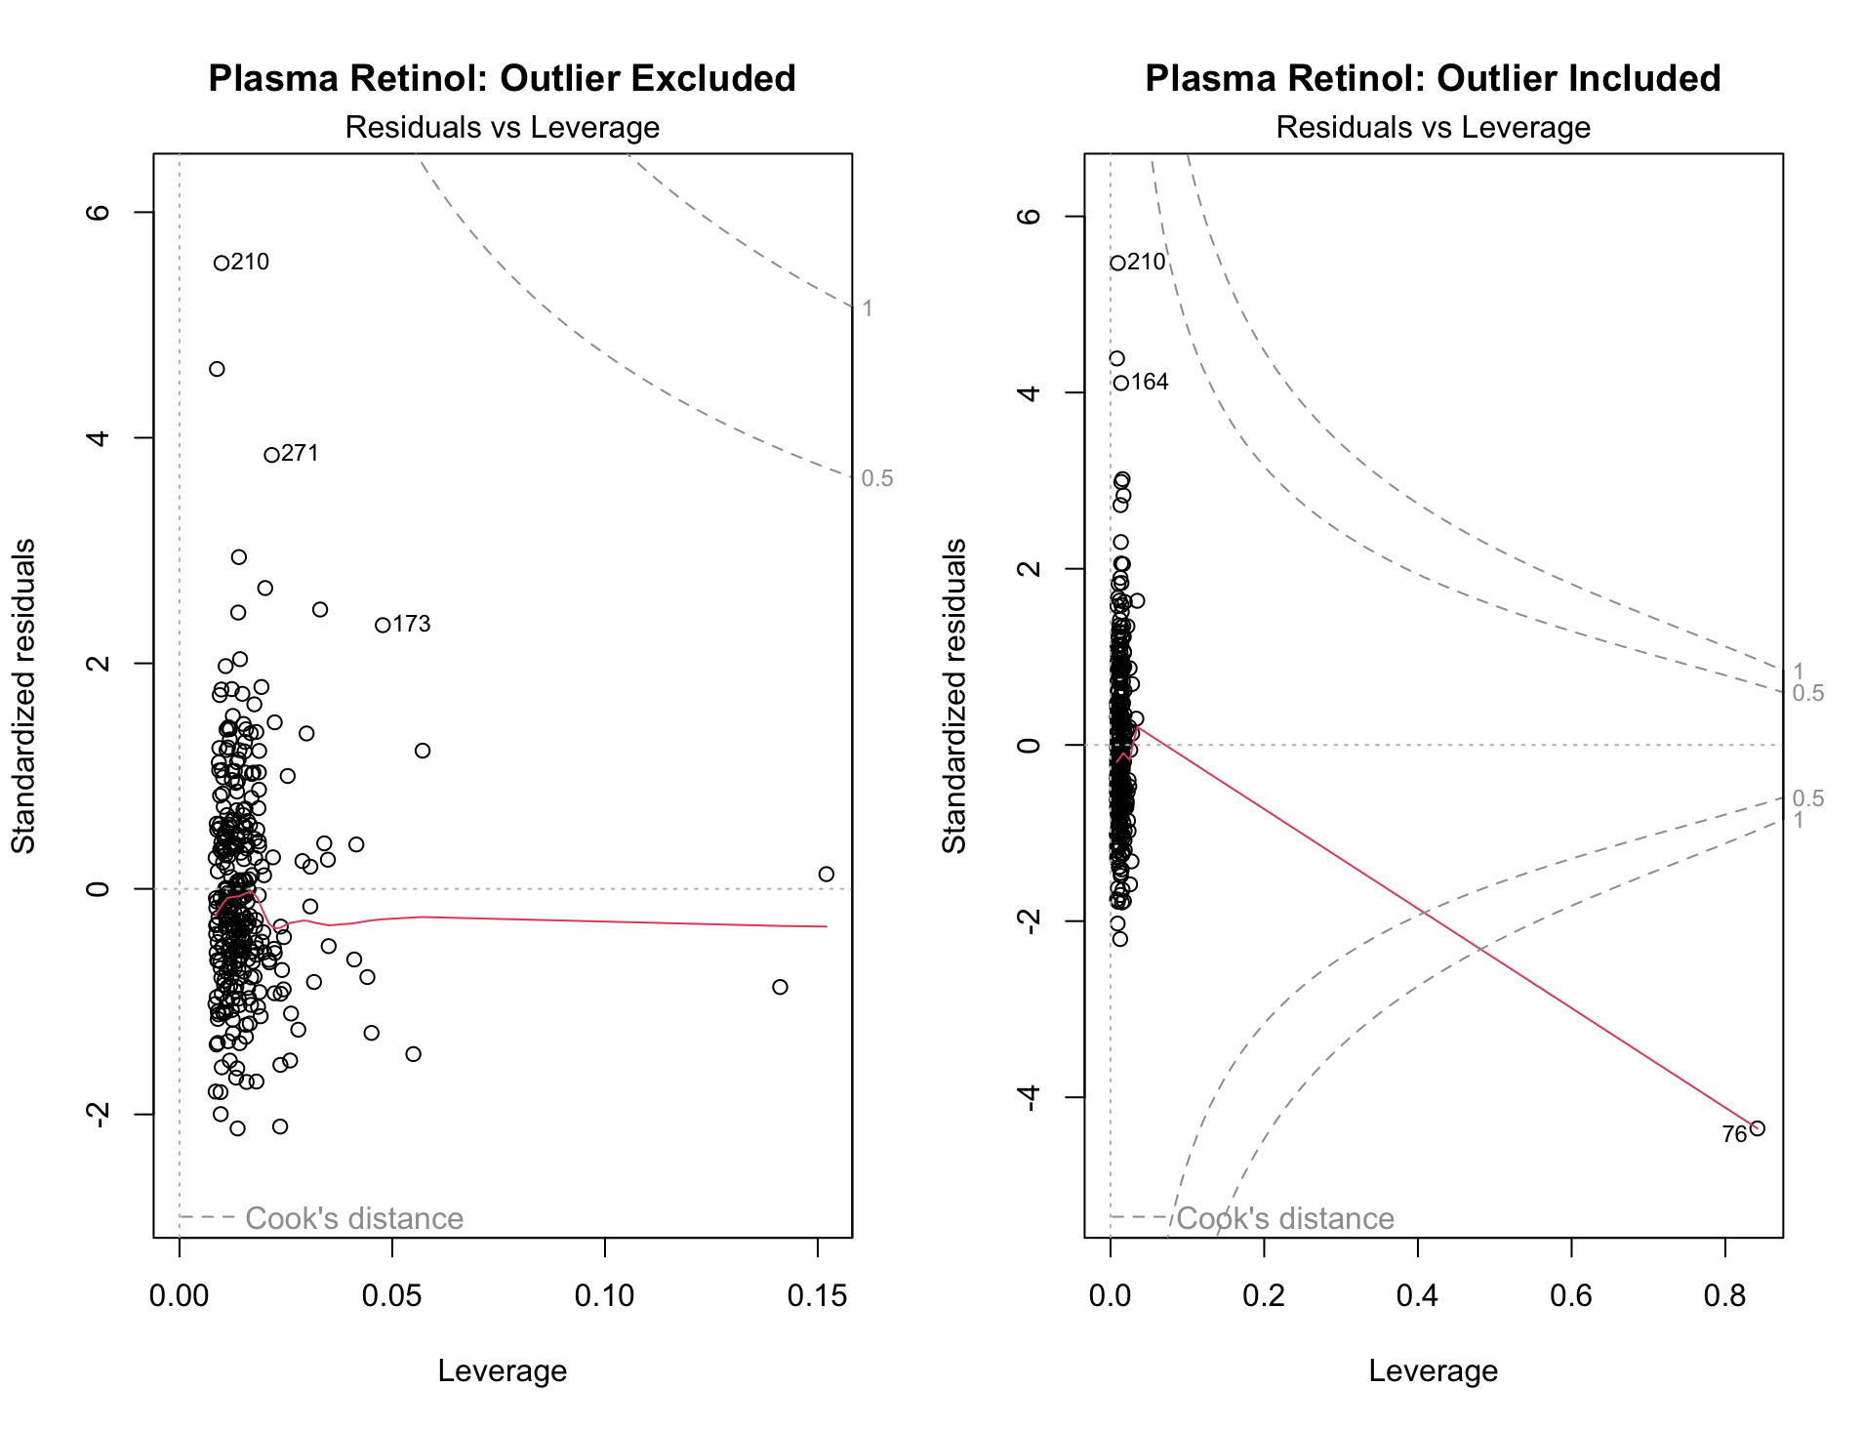
REFERENCES:

- Becker, S. W. (1961, February). Benign and Malignant Cutaneous Tumors in the Elderly. JAMA Dermatology. Retrieved from https://jamanetwork.com/journals/jamadermatology/article-abstract/526629

- Eliassen, A. (June 2015). Plasma carotenoids and risk of breast cancer over 20 y of follow-up. National Library of Medicine. Retrieved from https://pubmed.ncbi.nlm.nih.gov/25877493/

- Xie, L. (2019, July). Association of plasma retinol levels with incident cancer risk in Chinese hypertensive adults: a nested case-control study. National Library of Medicine. Retrieved from https://pubmed.ncbi.nlm.nih.gov/31352906/

- Kim, H.-I. (2018, July). Sex Differences in Cancer: Epidemiology, Genetics and Therapy. National Library of Medicine. Retrieved from https://www.ncbi.nlm.nih.gov/pmc/articles/PMC6029678/

- Hopkins, A. (2023, January). Study Probes Awareness of Alcohol’s Link to Cancer. National Cancer Institute - Cancer Currents Blog. Retrieved from https://www.cancer.gov/news-events/cancer-currents-blog/2023/cancer-alcohol-link-public-awareness

- Becker, S. W. (1961, February). Benign and Malignant Cutaneous Tumors in the Elderly. JAMA Dermatology. Retrieved from https://jamanetwork.com/journals/jamadermatology/article-abstract/526629

- Eliassen, A. (June 2015). Plasma carotenoids and risk of breast cancer over 20 y of follow-up. National Library of Medicine. Retrieved from https://pubmed.ncbi.nlm.nih.gov/25877493/

- Xie, L. (2019, July). Association of plasma retinol levels with incident cancer risk in Chinese hypertensive adults: a nested case-control study. National Library of Medicine. Retrieved from https://pubmed.ncbi.nlm.nih.gov/31352906/

- Kim, H.-I. (2018, July). Sex Differences in Cancer: Epidemiology, Genetics and Therapy. National Library of Medicine. Retrieved from https://www.ncbi.nlm.nih.gov/pmc/articles/PMC6029678/

- Hopkins, A. (2023, January). Study Probes Awareness of Alcohol’s Link to Cancer. National Cancer Institute - Cancer Currents Blog. Retrieved from https://www.cancer.gov/news-events/cancer-currents-blog/2023/cancer-alcohol-link-public-awareness

